Peer Evaluation for Lab 5 – Chapter 12
Your name: (Your lab is the one being evaluated) | Will Schultz
Name(s) of peer evaluator(s) | Kaiser
Date: | 05/25/2018

Instructions
You should have already completed Lab 5. After you and a peer have evaluated your work, you will submit this evaluation along with screen shots and source code indicated in moodle. You may make corrections to your work as a result of the evaluation.
In Class Exercises – Customer Maintenance Application
Completed Application?  - Implemented Add Customer Form?  - Added a private instance variable that will refer to a customer?  - Added a public method GetNewCustomer? Method instantiates and shows the form as a dialog box and returns the customer object?  - Added a click event handler on the ok button? Event handler validates all of the data, creates a new customer object with those values, sets the dialog result property and closes the dialog?  - Added a click event handler on the cancel button? Event handler sets the dialog result property and closes the dialog?  - Implemented Customer Maintenance Form?  - Added a private instance variable that will refer to a list of customer objects?  - Added a load event handler for the form? Event handler uses the static method GetCustomers in the CustomerDB class to load the Customers from the file? Uses a loop to iterate through each customer in the list, calls the method GetDisplayText on each customer object and adds that string to the list box on the form? Created a method on the form to fill the list box from the list (because it’s used in 3 places on the form)?  - Added a click event handler for the Add button? Instantiates an Add Customer Form and calls an appropriate method to display the form and get the new customer information? If the user clicked the ok button, add the customer to the list, save the customer list and re-fill the list box? If the user clicked the cancel button, doesn’t do anything?  - Added a click event handler for the Delete button? Removes customer from the list? Calls the save method in the DB class to save the changes? Refreshes the list? | Yes  Yes  Yes  Yes  Yes  Yes  Yes  Yes
One thing that you learned from using the class in an application:
I learned about using methods that are contained in different forms. I am having a hard time getting my head around doing this. I am so use to just calling a method that having to call it with the form name is weird and not natural for me to do.

Something that you’d like to continue working on:
I really want to do this lab again in the next few days for some extra practice working with classes. I think I relied on the product maintenance application as a reference too much. I definitely need it for some things, such as writing the confirm delete code, that is something I had no idea how to do.

Time you spent completing the application:
I spent maybe 20minutes working on this application.

Screen shot of the application running. Source code for UI.
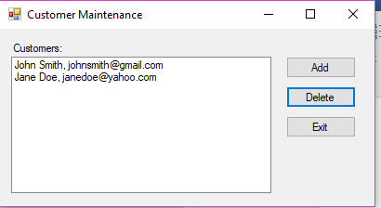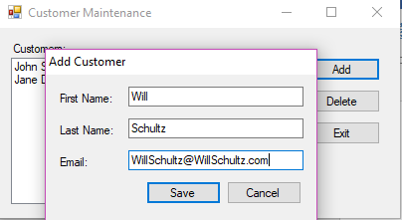
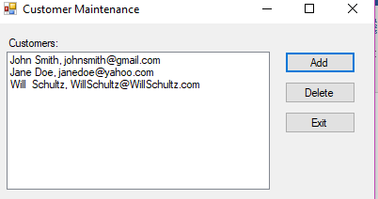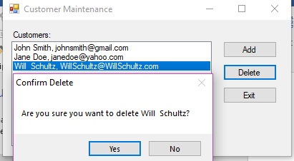
public partial class frmProductMain : Form
{
public frmProductMain()
{
InitializeComponent();
}

private List<Product> products = null;

private void frmProductMain_Load(object sender, System.EventArgs e)
{
products = ProductDB.GetProducts();
FillProductListBox();
}

private void FillProductListBox()
{
lstProducts.Items.Clear();
foreach (Product p in products)
{
lstProducts.Items.Add(p.GetDisplayText("\t"));
}
}

private void btnAdd_Click(object sender, System.EventArgs e)
{
frmNewProduct newProductForm = new frmNewProduct();
Product product = newProductForm.GetNewProduct();
if (product != null)
{
products.Add(product);
ProductDB.SaveProducts(products);
FillProductListBox();
}
}

private void btnDelete_Click(object sender, System.EventArgs e)
{
int i = lstProducts.SelectedIndex;
if (i != -1)
{
Product product = products[i];
string message = "Are you sure you want to delete "
+ product.Description + "?";
DialogResult button =
MessageBox.Show(message, "Confirm Delete",
MessageBoxButtons.YesNo);
if (button == DialogResult.Yes)
{
products.Remove(product);
ProductDB.SaveProducts(products);
FillProductListBox();
}
}
}

private void btnExit_Click(object sender, EventArgs e)
{
this.Close();
}
}

public partial class frmAddCustomer : Form
{
public frmAddCustomer()
{
InitializeComponent();

}

private Customer customer = null;

public Customer GetNewCustomer()
{
this.ShowDialog();
return customer;

}
private bool IsValidData()
{
return Validator.IsPresent(txtFirstName) &&
Validator.IsPresent(txtLastName) &&
Validator.IsPresent(txtEmail) &&
Validator.IsValidEmail(txtEmail);

}

private void btnSave_Click(object sender, EventArgs e)
{
if(IsValidData())
{

customer = new Customer(txtFirstName.Text, txtLastName.Text, txtEmail.Text);

this.Close();
}
}

Concentration Problem
Create a solution that included 3 project? (Windows form, class library, console app for testing?) Concentration GUI is the startup project? Added a using using statement in the concentration form to access the class library? Added a reference in the gui project to access the class library?
Added an instance variable that is an array of cards?
Methods that originally manipulated “Cards in the UI” now manipulate array of cards? Which methods are those?
Does the application function appropriately? Can you interact with the application in a way that causes it to “degrade” and not gracefully?
One thing that you learned from using the class in an application:

Something that you’d like to continue working on:

Time you spent completing the application:

Screen shot of the application running. Source code for the UI.

Programming style for all programs
Is proper indentation used? Is each event handler indented properly? Is each method indented properly?
Are comments used appropriately?
Do variable names use camel case? (camelCase for example)
Do property/method names use Title Case (or Pascal Case?)

General comments and notes from the evaluator:

One thing that you learned from completing the evaluation:

